**User Guide:**

To run the project locally, follow these steps:

1. Clone the repository:

git clone <https://github.com/VenkataSubramania1103/Plant-Disease-Detection.git>

1. Navigate to Project directory:

cd Plant-Disease-Detection

1. Install the required packages:

pip install -r requirements.txt

1. Run the streamlit application:

Python –m streamlit run plant_diseases_detection.py

1. Once the application is opened, upload the leaf image in format of jpg, jpeg or png from the Browse files option:

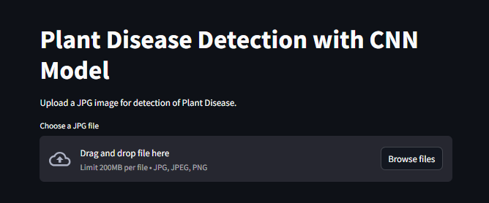

1. Once the image is uploaded the uploaded image will display and the detection will be right to it.

